Nigerian forces failed to act on mass abduction warnings: Amnesty
Rights group investigation says military and police received at least five calls hours before the attack by gunmen.
an hour ago

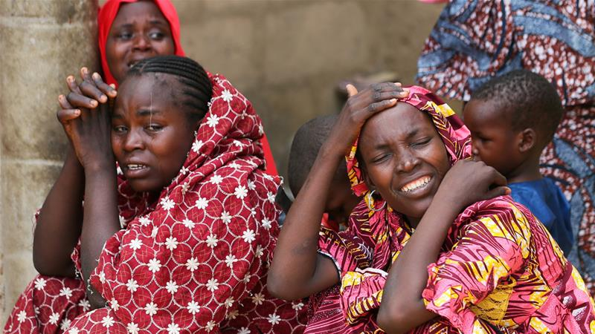
Nigeria's security forces failed to respond to warnings that armed men were on their way to a town where 110 schoolgirls were abducted last month, a human rights group alleged.
Amnesty International on Tuesday cited security sources, parents, and escapees as saying the military and police received at least five calls in the hours before the February 19 attack, which reminded many of the abduction of 276 Nigerian schoolgirls by Boko Haram in 2014.
Amnesty interviewed 23 people who recounted how about 50 fighters arrived in a convoy of nine vehicles as villagers attended evening prayers in the northern town of Dapchi, in Yobe state.
The first warning of the attack came hours earlier, when a phone call was made to the Nigerian army command about 50km away to say gunmen had been spotted in a village near Dapchi. The military commander responded by saying he was aware and monitoring it, the sources told Amnesty.
When the fighters later arrived in another village some residents called people in Dapchi to warn the convoy was headed their way, and one villager said he told the police.
OPINION

Note to Boko Haram: Western education is NOT a sin
by Mark Richmond
Villagers said the military did not arrive in Dapchi until shortly after the attack.

'Speak the truth'
Nigeria's military didn't immediately comment on the report.
"If the military disagrees let them come and say so," Bashir Manzo, the father of a 16-year-old schoolgirl abducted in the attack, told The Associated Press.
"If the military knew they were not going to act they should have informed us and we would have closed the school and asked all the girls to go home," Manzo said, adding parents have presented their information to the committee set up by Nigeria's president to investigate.
"There were security lapses which the military does not want to admit, but we shall speak the truth about what happened that day."
Nigerian schoolgirls not rescued after all
Amnesty urged Nigeria's government to make public the results of its investigation.
"Regrettably, no lessons appear to have been learned from the terrible events at Chibok four years ago," said Osai Ojigho, the group's Nigeria director.
"What happened in Dapchi is almost a carbon copy of what happened in Chibok, with the security forces failing to respond to warnings - and the same result for another hundred girls and their families."
Nigeria's President Muhammadu Buhari has called the mass abduction a "national disaster". The military withdrew from the town in January,
the situation appeared to be calm there.
Parents and educators in Africa's most populous country have raised an outcry in response to the attack, demanding better security for schools in the vast region where Boko Haram has kidnapped thousands of people over nearly a decade.

